## PROJECT REPORT ON

FACEREC

Submitted to

#### SARDAR PATEL UNIVERSITY MANDI (H.P.)

**(A STATE GOVT. UNIVERSITY)**

For the partial fulfillment for the degree of MCA



#### SESSION 2023-2025

***Under the Supervision of: Submitted by:***

##### Mrs. Ruchi Thakur Aditya Rana

**Roll No: 202301504127001**

#### DEVELOPED AT DEPARTMENT OF COMPUTER SCIENCE SARDAR PATEL UNIVERSITY MANDI (H.P)

**CERTIFICATE – I**

This is to certify that this project report entitled “**FACEREC**” Submitted to Department of Computer Application, Sardar Patel University Mandi in partial fulfilment of the requirement for the degree of **MASTER OF COMPUTER APPLICATION (MCA)**, is original work carried out by **ADITYA RANA**, under my guidance. The matter embodied in this project is genuine work done by the student’s and has not been submitted whether to this University or to any other University / Institute for the fulfilment of the requirement of any course of study.

##### Place: Mandi Name & Sign of Guide:

**Date:** Mrs. Ruchi Thakur

**CERTIFICATE - II**

## ACKNOWLEDGEMENT

I would like to take this opportunity to express my profound gratitude to all those who have played an instrumental role in the successful completion of this project.

First and foremost, I am sincerely grateful to **Prof. Rajesh Kumar Sharma, Dean Physical Sciences**. His invaluable insights, leadership, and continuous support have greatly contributed to the successful completion of this project. His dedication to fostering academic excellence and his willingness to assist at every step have been instrumental in shaping the outcome of this work

I am also deeply indebted to my project guide, **Mrs. Ruchi Thakur** from the **Department of Computer Science**. Her unwavering support, insightful guidance, and constant encouragement have been invaluable throughout the various stages of this project. Her expertise and dedication have not only provided me with the knowledge to accomplish this work but also inspired me to reach higher levels of academic and professional excellence.

I would also like to extend my heartfelt thanks to my parents, whose blessings have always been a guiding light in my life. Their unconditional love, patience, and understanding have been a constant source of motivation, enabling me to overcome every challenge and obstacle that came my way during this project. Without their support and belief in my abilities, this achievement would not have been possible.

I would also like to acknowledge the support of the entire Department of Computer Science and the campus staff. Their contributions, whether through administrative support or technical assistance, have played a crucial role in the smooth execution of this project.

Lastly, I offer my humble thanks to the divine power, whose blessings and grace have provided me with the strength and clarity of mind needed to see this project through to its completion.

This project is a culmination of collective efforts, and I am truly grateful to everyone who has been a part of this journey.

#### ADITYA RANA

**TABLE OF CONTENTS**

###### PAGE NO.

###### Chapter 1 INTRODUCTION 1-13

###### Introduction to the institute

###### Introduction to the Project

###### Chapter 2 SDLC (SOFTWARE DEVELOPMENT LIFE CYCLE) 14-17

###### Chapter 3 REQUIREMENT ANALYSIS 18-22

###### Requirement gathering

###### Functional Requirements

###### Non – Functional Requirements

###### Chapter 4 SOFTWARE DESIGN 23-29

###### Chapter 5 LANGUAGE & SOFTWARE TOOLS 30-32

* 1. Python
  2. OpenCV
  3. Numpy
  4. Requests

###### Chapter 6 PROJECT DESIGN 33-36

* 1. System Components
  2. Functional Requirements
  3. Data Flow Diagram
  4. Database Design
  5. User Interface Design

###### Chapter 7 PROJECT SOURCE CODES & SCREENSHOTS 37-42

* 1. Project Screenshots

###### Chapter 8 TESTING 43-51

* 1. Objectives
  2. Types of Testing
  3. Testing Tools
  4. Reporting & Documentation
  5. Defect Management
  6. Exit Criteria

###### Chapter 9 DEPLOYMENT 52-56

* 1. Objectives
  2. Deployment

Chapter 10 CONCLUSION 57-58

Chapter 11 BIBLIOGRAPHY 59-62

# CHAPTER 1



**INTRODUCTION**



COMPANY PROFILE

**ABOUT US**

**EXCELLENCE TECHNOLOGY (ET)** is India based leading strategic IT Company offering integrated IT solutions with the vision to provide Excellence in software solution. We at EXCELLENCE TECHNOLOGY bring innovative ideas and cutting edge technologies into business of customers. EXCELLENCE TECHNOLOGY is having rich experience in providing high technology end to end solutions in **MOBILE APP AND WEB DEVELOPMENT.**

4

**PHILOSOPHY**

* To impart hardcore practical quality training among students/developers about latest technologies trending today.
* To share knowledge of information security and create awareness in the market. The solution to clients' as per the International standard practices and governance.
* To support good business practices through continual employee training and education
* To equip a local team with a strong knowledge of international best practices and international expert support so as to provide practical advisories in the best interests of our clients

**OUR MISSION**



To Protect Client's information system by

Detecting Threats, Deterring Attacks, and provide best solution in the ever changing

Info - Security Challenges. We accomplish this by integrating our People, Process, and Technology in the most efficient way to increase value for all stakeholders

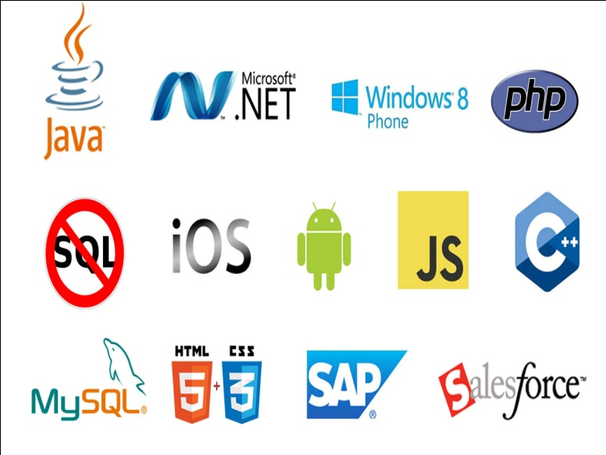**OUR SERVICES**

* RISK Management Services
* Quality Control
* Business Process Re-Engineering
* Network Risk Analysis
* Software Testing
* Mobile Application Testing
* Wireless Penetration Testing
* Network Penetration Testing
* Application Security Testing

**OUR SERVICES IN SOFTWARE DEVELOPMENT**

***We are proficient in all platforms of software Development practices — Agile, SCRUM, Lean, Waterfall, Prototype, Incremental, Iterative, and V-Model.***

With the EXCELLENCE TECHNOLOGY experience the incredible services such as agile software development and the problems related to outsourcing. We comprise of the team of experienced and professionals’ members who with their skills efficiently get the job done and innovatively help you to transform your ideas into the successful business.



Why Choose Us?

* **Hundreds of Clients & Nearly a Decade of Experience**
* **Goal Oriented, ROI-Driven Focus**
* **A Streamlined / Quality-Driven Process**
* **Talented Designers & Expert Developers**
* **Our Websites & E-marketing Platforms are Easy to Manage**
* **We Are Dedicated to Our Clients’ Success**
* **EXCELLENCE TECHNOLOGY** is steadfast to undertake the projects cutting edge to technology competence and know-how abilities. The project execution is held with dedication and responsibility to perform our best with the essence of knowledge, creativity and skills to the utmost and efficiently.
* At **EXCELLENCE TECHNOLOGY,** we have competence to expand and adjust as per client specific requirements.
* **Skilled Workforce:** At EXCELLENCE TECHNOLOGY you deal with the highly professional and proficient employees.
* **Cost Efficiency:** We help you to reduce the unnecessary investment and ask for the reasonable amount of money.
* **Quality Of the Product:** Our software service sector has been maintaining the highest international standards of quality.
* **Infrastructure:** Well organized team and tools to handle the projects with responsible approach Hardware, Software, Networking, Voice, Conferencing, disaster recovery all infra all you need for international projects.
* **Ongoing Involvement:** EXCELLENCE TECHNOLOGY products are “built for change” as we are well responsive that the necessity to improve a Web solution generally arises even before the solution is out of the door. We deliver long-term product enhancement if desired.
* **Partnership:** EXCELLENCE TECHNOLOGY considers every client a partner. From the initial stages, you are closely involved into the procedure of technical classification, development, and testing.

**OUR CLIENTS**



**KEY PROFESSIONALS:**

In addition to a panel of eminent consultants and advisors, we have a dedicated pool of trained Developers and Trainer, investigators, working under the guidance of professional managers. **“A Ship is as good as the crew who sail her**.**”** Our Technical team of professionals handing, designing & delivering of projects has a strong presence in the North India & the US. Our engineers are already working on the latest technologies like **I-Phone & Android** Applications, **Robotics**, **VLSI-VHDL**, Embedded System, Networking and **Cloud computing.** Some of the key professionals and advisors are listed below:

**Mr. Deepak Kashyap:** (**Branch Manager**)

He is the backbone of Excellence Technology and a man with more than 10-year rich practical experience who believes in taking up new ventures and projects. Head-IT, Global Award Winner from India for AGILE and OPEN GRAPH implementation in **Sudan Taxation Chamber**. Divisional Award and Star Award Winner in Year 2011 for his exemplary work in process improvement for IT Service Delivery Domains. MASTERS in Computer applications and Certified from PTU Certification. Holds total of 10 Years of rich experience including 5 Years in Information Security Implementation, Maintenance and Auditing and initial over 10 years’ experience in Project Management, Client Relationship Management and Server, Desktop and IT Service Delivery.

**Ms. Sunita Thakur: (Dean Academics**)

A Woman who believes that “Honour Time & Place, then you will be honoured.” She has more than 4 years solid industrial experience in a software companies & is very dashing and innovative in her technical approach. MCA, Diploma in Information Technology, expertise in search engine optimization and webdesigning.

**Mr. Gurpreet Singh: (Technical Head - Python & GIT HUB)**

A man who strongly feel that “Nothing is Impossible”. A very committed team leader who has been professionally attached with Multinational companies for more than 18 years and has led the marketing teams in all states of North India. MCA (Engineering), in computer Science PTU Approved trained and Certified. Successfully MCA master degree Training program for a leading Technology. Holds total of 5 Years of rich experience including 3 Years in Software developer, Maintenance and Auditing and initial over 4 years’ experience in Project Management, Client Relationship Management and IT Service Delivery.

**Miss. Anjali Sharma : (Sr. Counselor)**

A woman who believes that “Challenges are what make life interesting and overcoming them is what makes life meaningful.” She has more than 3years experience in business development. B.A. – (Punjab University) Lead Consultant - Due Diligence, Strategy, Operations, Business Continuity, Risk Management, Mergers & Acquisitions.

**Mr. Akshit Dogra: (Mechanical Head)**

A man believes that “don’t wait for extra ordinary opportunities, seize common occasions and make them great.” He has more than 4 years’ experience in marketing field. B. Tech (Mech), Engineer and Value, is an approved by AICTE (HPTU). He is having total 5 years of experience in 3 years of experience in AutoCAD, Solid works, Catia, Pro-e, Ansys etc.

**Mr. Paramveer Singh : (Mobile Application & Web Developer)**

B.Tech(CSE) – IKG-PTU, Expertise in Reviewing current systems, presenting ideas for web development soft wares, including Application software’s, working closely with analysts, Senior Developers, Programmers, designers and staff, Producing detailed specifications and writing the program codes, Testing the product in controlled, real situations before going live, Preparation of training manuals for users and maintaining the systems once they are up and running

**Corporate Office:** C-133, First Floor

Industrial Area, Phase-8, Sector-72, Mohali .

**PH.**:0172-4698755,93177-88822 ,93562-55522

**E-MAIL**: excellencehead@gmail.com,

**URL:** www.excellencetechnology.in

## INTRODUCTION TO THE PROJECT

This project focuses on **real-time human face analysis** from a live video feed, performing three key tasks simultaneously: **face recognition**, **age estimation**, and **gender classification**. It leverages computer vision techniques and pre-trained models to provide information about individuals detected in the video stream.

The core functionalities include:

1. **Face Detection:** Identifying the presence and location of faces within each video frame using a Haar Cascade classifier.
2. **Face Recognition:** Recognizing known individuals by comparing detected faces against a trained model. This part of the project uses the **Local Binary Patterns Histograms (LBPH)** algorithm, trained on a custom dataset of images for specific individuals (e.g., 'Aditya').
3. **Age and Gender Detection:** Estimating the age range and classifying the gender (Male/Female) of each detected face. This is achieved by utilizing **pre-trained deep learning models (DNNs)** for age and gender prediction, downloaded and loaded at runtime.

The project processes the video feed frame by frame, performing face detection first. For each detected face, it then applies the trained LBPH model for recognition and the pre-trained DNN models for age and gender estimation. The results (recognized name, age, and gender) are overlaid onto the live video feed displayed to the user.

**Methodology:**

* **Face Detection:** Employing OpenCV's Haar Cascade classifier for efficient face localization.
* **Face Recognition:** Training an LBPH model on a collection of facial images of known individuals. During runtime, the model predicts the identity of detected faces based on learned patterns.
* **Age and Gender Detection:** Utilizing pre-trained Caffe models (age_net.caffemodel, gender_net.caffemodel) and their corresponding prototxt files (age_deploy.prototxt, gender_deploy.prototxt) within OpenCV's DNN module. Detected face regions are processed through these networks to obtain age and gender predictions.

**Data and Models:**

* **Face Recognition Training Data:** A custom dataset containing images of individuals to be recognized.
* **Pre-trained Models:** Publicly available pre-trained deep learning models for age and gender detection, sourced from the OpenCV extra repository.

This project demonstrates the application of computer vision and machine learning techniques for practical real-time face analysis tasks, combining traditional methods like LBPH with deep learning for enhanced capabilities.

##### Objectives of FaceRec

The development of the **FACEREC** project, a real-time face analysis system, is driven by the following core objectives:

1. **Develop a Real-Time Face Analysis System:** To create a functional system that can process a live video feed to detect and analyze human faces in real-time.
2. **Implement Accurate Face Recognition:** To build and integrate a face recognition module capable of identifying known individuals from a custom dataset using techniques like LBPH.
3. **Integrate Age and Gender Estimation:** To incorporate pre-trained deep learning models to accurately estimate the age range and classify the gender of detected faces.
4. **Provide Clear Visual Output:** To design the system to display the results of face detection, recognition, age, and gender analysis directly on the live video stream for immediate user feedback.
5. **Demonstrate Core Computer Vision Capabilities:** To showcase the practical application of fundamental computer vision techniques (like Haar Cascades) and deep learning (for age/gender) in a combined, real-time application.
6. **Create a Foundation for Further Development:** To establish a base system that can be extended with additional facial analysis features in the future, such as emotion detection or attendance tracking.

In this project, we will be using Deep Learning (CNN) and Computer Vision.

**WHAT IS DEEP LEARNING:**

Machine Learning (ML) and Deep Learning are subsets of Artificial Intelligence. Deep Learning represents the next evolution in Machine Learning. In Deep Learning, the model learns through an artificial neural network that is very much similar to a human brain and this allows the model to analyze data in a structure much similar to humans do. Deep Learning models don’t require a human programmer to intervene and tell what to do with the data. It is self-capable of learning from the extraordinary amount of data provided to it.

Deep learning is a machine learning technique that teaches computers to do what comes naturally to humans: learn by example. Deep learning is a key technology behind driverless cars, enabling them to recognize a stop sign, or to distinguish a pedestrian from a lamppost. It is the key to voice control in consumer devices like phones, tablets, TVs, and hands-free speakers. Deep learning is getting lots of attention lately and for good reason. It’s achieving results that were not possible before.

In deep learning, a computer model learns to perform classification tasks directly from images, text, or sound. Deep learning models can achieve state-of-the-art accuracy, sometimes exceeding human-level performance. Models are trained by using a large set of labelled data and neural network architectures that contain many layers.

In a word, accuracy. Deep learning achieves recognition accuracy at higher levels than ever before. This helps consumer electronics meet user expectations, and it is crucial for safety-critical applications like driverless cars. Recent advances in deep learning have improved to the point where deep learning outperforms humans in some tasks like classifying objects in images.

While deep learning was first theorized in the 1980s, there are two main reasons it has only recently become useful:

Deep learning requires large amounts of labelled data. For example, driverless car development requires millions of images and thousands of hours of video.

Deep learning requires substantial computing power. High-performance GPUs have a parallel architecture that is efficient for deep learning. When combined with clusters or cloud computing, this enables development teams to reduce training time for a deep learning network from weeks to hours or less.

**What is a Neural Network?**

A neural network is a series of algorithms that endeavors to recognize underlying relationships in a set of data through a process that mimics the way the human brain operates. In this sense, neural networks refer to systems of neurons, either organic or artificial in nature. Neural networks can adapt to changing input; so, the network generates the best possible result without needing to redesign the output criteria. The concept of neural networks, which has its roots in [artificial intelligence](https://www.investopedia.com/terms/a/artificial-intelligence-ai.asp). is swiftly gaining popularity in the development of [trading systems.](https://www.investopedia.com/articles/trading/11/automated-trading-systems.asp)

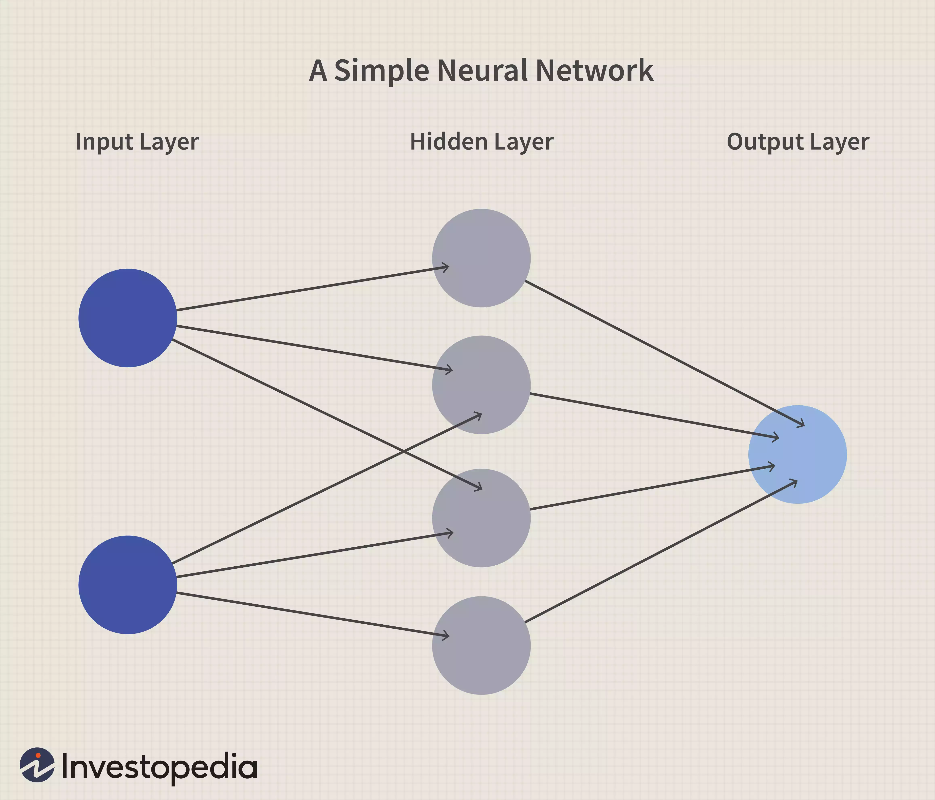

**Basics of Neural Networks**

Neural networks, in the world of finance, assist in the development of such process as time-series forecasting, [algorithmic trading](https://www.investopedia.com/terms/a/algorithmictrading.asp), securities classification, credit risk modeling and constructing proprietary indicators and price [derivatives](https://www.investopedia.com/terms/d/derivative.asp).

A neural network works similarly to the human brain’s neural network. A “neuron” in a neural network is a mathematical function that collects and classifies information according to a specific architecture. The network bears a strong resemblance to statistical methods such as curve fitting and regression analysis.

A neural network contains layers of interconnected nodes. Each node is a perceptron and is similar to a [multiple linear regression](https://www.investopedia.com/terms/m/mlr.asp). The perceptron feeds the signal produced by a multiple linear regression into an activation function that may be nonlinear.

**COMPUTER VISION:**

Computer vision provides the ability for the computer to see as humans see. It is the part of computer science that is focused on replicating the intricate parts of the human visual system. It helps identify and process the objects in images through the computer.

Deep learning has delivered superhuman accuracy for image classification, object detection, image restoration, and image segmentation. It uses enormous neural networks to teach machines how to automate the tasks performed by human visual systems. It is a field that aims to gain a deep understanding through digital images or videos.

**INTRODUCTION TO OpenCV:**

There are some predefined packages and libraries in python as part of Computer Vision which can make our life quite simple and OpenCV is one of them. It helps us develop a system that can process images and real-time video using computer vision. OpenCV (Open-Source Computer Vision Library) is an open-source computer vision and machine learning software library which is easy to import in Python. We will be using [HaarCascade](https://medium.com/swlh/haar-cascade-classifiers-in-opencv-explained-visually-f608086fc42c) algorithm in the model. It is a machine learning-based approach where a cascade function is trained using a whole lot of positive and negative images. It is then used to detect objects in other images.

We’re using Google Colab as part of this blog. It’s a browser-based Jupyter notebook service that’s available for free. This service is fit for Deep Learning and Machine Learning applications. It does not require any additional setup or installation. It helps us to run Python code via the browser. It also allows us to share these notebooks without having to download them.

# CHAPTER 2



**SDLC (SOFTWARE DEVELOPMENT LIFE CYCLE)**

## SDLC (SYSTEM DEVELOPMENT LIFE CYCLE)

The System Development Life Cycle (SDLC) is a structured process used for planning, developing, testing, and deploying an information system. SDLC is crucial in software engineering as it ensures a systematic approach to building software systems, helping to minimize risks and ensure that the final product meets the required specifications and user needs. It encompasses several stages, each critical to the successful completion of a software project. These stages typically include planning, analysis, design, implementation, testing, deployment, and maintenance.

In the context of the **FACEREC** project, the SDLC provides a comprehensive framework that guides the development of the system from its conceptualization to its deployment. One of the most critical phases within the SDLC is the Feasibility Study, which assesses the viability of the project before significant resources are invested.

**Feasibility Study**

A Feasibility Study is a crucial step in the SDLC, as it evaluates the practicality of a proposed project and determines whether it is worth pursuing. It involves analyzing various aspects of the project, such as economic, technical, legal, and resource feasibility, to ensure that the project can be successfully executed within the given constraints. This study is vital to understanding potential risks and challenges that could impact the development and eventual success of the project.

1. **Feasibility and Risk Analysis**

Feasibility and risk analysis are inherently connected. A high-risk project is less likely to produce quality software, which reduces its feasibility. Therefore, during the feasibility study, particular attention is given to identifying and analyzing potential risks. This includes evaluating the project's economic, technical, legal, and resource-related aspects, ensuring that any risks are understood and mitigated as much as possible.

1. **Economic Feasibility**

Economic feasibility assesses the financial aspects of the project. It involves weighing the development costs against the expected benefits or income derived from the system once it is operational. In the case of the **FACEREC** project, since this initiative was developed as part of an academic project, there were no direct development costs involved in terms of commercial licensing for core libraries like OpenCV or purchasing pre-trained models which are publicly available.

However, an economic feasibility assessment remains crucial, particularly when considering future scalability, potential deployment scenarios (e.g., requiring specific hardware like GPUs for performance), and potential commercialization. Although the initial development did not incur significant direct costs, the economic feasibility also considers long-term maintenance, potential updates (e.g., retraining models with new data), and the scalability of the platform. It assesses whether the benefits, such as enhanced security through recognition, improved user interaction, or potential application in various industries, outweigh the costs involved in maintaining and upgrading the system.

1. **Technical Feasibility**

Technical feasibility determines whether the current technology is adequate to meet the project requirements. It evaluates whether the technological infrastructure available can support the development and functioning of the system as specified.

For the **FACEREC** project, the feasibility study confirmed that the technology required to develop the system was not only available but also up-to-date with industry standards in computer vision and machine learning. The solution is technologically feasible, utilizing robust and scalable technologies like OpenCV, Python, and pre-trained deep learning models that ensure the system can handle the anticipated real-time processing load and performance requirements on suitable hardware. The system's architecture is designed to be adaptable, allowing it to leverage advancements in computer vision algorithms and hardware acceleration (like GPUs) for future improvements. This flexibility is crucial for ensuring the system's longevity and relevance in a rapidly evolving digital environment.

1. **Legal Feasibility**

Legal feasibility involves evaluating any legal constraints or issues that might arise during the development of the project. This includes checking for any potential infringement, violation, or liabilities that could result from the development and deployment of the system.

For **FACEREC**, the legal feasibility was assessed primarily in terms of data privacy and usage of publicly available libraries and models. Ensuring compliance with data protection regulations (if handling personal data beyond the scope of an academic project) and adhering to the licenses of libraries like OpenCV and the pre-trained models used is vital to prevent any future liabilities that could hinder the project’s success or lead to legal challenges. As an academic project, the focus is on demonstrating technical capability, but awareness of these legal aspects is important for potential future development.

1. **Resource Availability**

Resource availability is a critical factor in the feasibility study, as it assesses whether the necessary resources—both human and material—are available to develop and deploy the system. This includes the availability of skilled personnel, the necessary hardware and software, and any other resources required to build the system effectively.

For the **FACEREC** project, all essential resources were readily available for the academic context. The development team comprised individuals with skills in Python programming and computer vision concepts. The necessary software (OpenCV, Python libraries) and hardware (a computer with a webcam) were accessible. The technology used in the project, leveraging established libraries and readily available models, ensures that the system can be developed and run on standard computing environments.

1. **Risk Mitigation**

Risk mitigation is an integral part of the feasibility study, focusing on identifying potential risks and developing strategies to minimize their impact. In the case of **FACEREC**, several potential risks were identified during the feasibility study, including the accuracy limitations of the recognition/age/gender models, performance issues on less powerful hardware, and challenges in building a sufficiently diverse training dataset for recognition.

To mitigate these risks, the project focused on using well-established libraries and pre-trained models known for their performance. The LBPH model, while simpler than deep learning for recognition, is computationally less intensive for real-time applications. For age and gender, using pre-trained DNN models leverages significant prior research. Future mitigation could involve exploring more advanced models, optimizing code for performance, and collecting more varied training data if extending the recognition capabilities. Testing with different hardware configurations and under various lighting conditions also helps identify and plan for potential performance issues.

# CHAPTER 3



**REQUIREMENT ANALYSIS**

**Requirement Analysis** is a critical phase in the System Development Life Cycle (SDLC) that involves gathering, analyzing, and documenting the necessary requirements for a software system. It sets the foundation for the entire project by ensuring that the development team understands what the users need and expect from the system. This phase is crucial for the successful execution of the project as it defines the scope, functionalities, and objectives that the system must fulfill. For the **FACEREC** project, the requirement analysis phase involved defining the specific capabilities needed for a real-time face analysis system, focusing on detection, recognition, age, and gender estimation from a live video feed.

1. **Stakeholder Identification and Requirement Gathering**

The first step in the requirement analysis process was identifying the key stakeholders of the **FACEREC** system. Given the nature of this project as likely an academic endeavor or a personal development project, the primary stakeholder is the developer/user themselves, who defines the system's capabilities and evaluates its performance. In a potential future deployment scenario, stakeholders could expand to include end-users who interact with the system or administrators who manage it.

The requirement gathering process for **FACEREC** primarily involved:

* **Self-Reflection and Goal Definition:** The developer defined the core goals of the project based on their interest in computer vision and face analysis. This involved deciding which specific features (face detection, recognition, age, gender) would be included.
* **Review of Technical Documentation and Examples:** Exploring the capabilities of libraries like OpenCV and researching existing examples of face analysis projects helped in understanding what is technically feasible and how to implement specific features.
* **Defining the Scope:** Clearly outlining the boundaries of the project – focusing on real-time analysis from a webcam feed and the selected analysis tasks – helped manage expectations and define the necessary requirements.

These methods helped in translating the initial concept into a set of concrete requirements for the system.

1. **Functional Requirements**

Functional requirements define the specific functionalities that the **FACEREC** system must perform to meet its objectives. These requirements focus on *what* the system should do, encompassing the various operations and features that will be part of the final product. For the **FACEREC** project, the key functional requirements include:

* **Video Capture:** The system must be able to access and capture a live video stream from a connected webcam.
* **Frame Processing:** The system must be able to process individual frames from the video stream sequentially and in real-time.
* **Face Detection:** The system must be able to accurately detect the presence and location of human faces within each video frame using a Haar Cascade classifier.
* **Face Recognition:** For each detected face, the system must be able to apply a trained LBPH model to predict the identity of the individual from a set of known individuals.
* **Age Estimation:** For each detected face, the system must be able to estimate the age range of the individual using a pre-trained deep learning model.
* **Gender Classification:** For each detected face, the system must be able to classify the gender (Male/Female) of the individual using a pre-trained deep learning model.
* **Model Loading:** The system must be able to load the pre-trained LBPH model for face recognition and the pre-trained DNN models for age and gender detection at the start of the application.
* **Model File Management:** The system should be able to handle the downloading of the pre-trained age and gender model files if they are not available locally.
* **Result Visualization:** The system must be able to overlay the analysis results (bounding box, recognized name, recognition confidence, estimated age, estimated gender, and their confidences) onto the live video frame.
* **Real-Time Display:** The system must display the annotated video feed to the user in real-time.
* **Application Control:** The system must allow the user to gracefully exit the application (e.g., by pressing a specific key).

1. **Non-Functional Requirements**

Non-functional requirements refer to the quality attributes of the system, focusing on *how* the system should perform rather than what it should do. These requirements are crucial for ensuring that the **FACEREC** system meets performance standards, provides a good user experience, and is reliable and maintainable. The key non-functional requirements for the project include:

* **Performance:**
  + - **Real-Time Processing:** The system should process video frames and perform analysis quickly enough to provide a smooth, real-time output without significant lag.
    - **Processing Speed:** The time taken to detect, recognize, and estimate age/gender for each face in a frame should be minimized.
    - **Frame Rate Handling:** The system should ideally process frames at a rate close to the webcam's frame rate to avoid dropping frames and causing choppiness.
  + **Accuracy:**
    - **Detection Accuracy:** The face detector should reliably identify faces under varying conditions (lighting, angles, etc.).
    - **Recognition Accuracy:** The LBPH model should accurately identify known individuals with high confidence and correctly indicate when a face is not recognized.
    - **Estimation Accuracy:** The age and gender models should provide reasonably accurate estimations.
  + **Usability:**
    - **Simple Interface:** The user interface (the display window) should be straightforward and easy to understand, clearly presenting the analysis results.
    - **Ease of Setup:** The project should be relatively easy to set up and run, requiring minimal configuration once dependencies are installed.
  + **Reliability:**
    - **Stability:** The application should run without crashing or encountering frequent errors during continuous operation.
    - **Robustness:** The system should handle cases where faces are not detected or where predictions have low confidence gracefully.
  + **Maintainability:**
    - **Code Clarity:** The codebase should be well-organized and commented to facilitate understanding and future modifications.
    - **Modularity:** The design should allow for potential updates or replacements of specific components (e.g., swapping the LBPH model for a deep learning-based recognition model) with minimal impact on other parts of the system.

1. **Prioritization of Requirements**

Once the requirements were defined, they were prioritized based on their importance for achieving the core objectives of the **FACEREC** project. This prioritization helped guide the development process, ensuring that the most critical features and quality attributes were addressed first.

High-priority functional requirements included the core analysis tasks: video capture, face detection, face recognition, age estimation, gender classification, and real-time visualization of results. Without these, the fundamental purpose of the project would not be met. Loading models and application control (exiting) were also considered essential for a functional application.

Among non-functional requirements, **Performance (Real-Time Processing)** and **Accuracy (especially Face Detection and Recognition)** were given high priority, as they directly impact the perceived effectiveness and usability of the system. Usability (simple interface) and Reliability (stability) were also important to ensure the application is functional and easy to use. Maintainability is important for future development but might be slightly lower priority in an initial academic version compared to core functionality and performance.

1. **Documentation and Validation**

The final step in the requirement analysis phase was the documentation and validation of the gathered requirements. All functional and non-functional requirements were documented, serving as a reference throughout the development process.

* + **Documentation:** Requirements were documented within the project report or technical documentation, outlining the expected behavior and quality attributes of the system. Code comments also served as a form of documentation, explaining the implementation details related to specific requirements.
  + **Validation:** Validation involved testing the developed system against the defined requirements. This included:
    - Testing video capture and display.
    - Testing face detection with different individuals, lighting conditions, and angles.
    - Testing face recognition with known and unknown individuals to assess accuracy and confidence levels.
    - Testing age and gender estimation with various faces.
    - Evaluating the real-time performance and smoothness of the output.
    - Ensuring the exit mechanism functions correctly.

This validation process confirmed that the developed **FACEREC** system met the intended requirements and performed as expected within the defined scope.

# CHAPTER 4



**SOFTWARE DESIGN**

## SOFTWARE DESIGN:

Software Design is a critical phase in the System Development Life Cycle (SDLC)

that focuses on defining the architecture, components, interfaces, and other

elements necessary to create the software system. This phase translates the

requirements gathered during the Requirement Analysis phase into a blueprint

that guides the development team in building the actual system. It involves

making strategic decisions about how the system will be structured, how its parts

will interact, and how data will be managed. A well-defined software design

minimizes ambiguity, reduces the likelihood of errors during implementation,

and facilitates easier maintenance and future modifications. For the FACEREC

project, the software design phase involved the creation of a detailed design that

would support real-time face detection, recognition, age estimation, and gender

classification from a live video feed, ensuring the system is efficient and

effective for its intended purpose.

1. **Architectural Design**

The architectural design serves as the backbone of the FACEREC project, defining

the overall structure and organization of the system. It provides a high-level view

of the system, outlining its main components and their relationships. Given the

real-time nature of the application and its focus on processing a single video

stream sequentially, a relatively straightforward architecture, perhaps best

described as a processing pipeline, is highly suitable. This architectural choice

emphasizes the flow of data through a series of processing steps. The architecture

was designed to ensure efficient processing of video frames, prioritizing low

latency for a responsive real-time experience, while also being flexible enough to

accommodate potential future enhancements like adding other facial analysis

features such as emotion detection or head pose estimation.

**1.1. Processing Pipeline Architecture**

The FACEREC system employs a processing pipeline architecture, where video

frames flow sequentially through different stages of analysis. Each stage

performs a specific task and passes its output to the next stage in the pipeline.

This modular approach helps in separating concerns, making the system easier to

develop, debug, and maintain. If an issue arises in one stage, it can often be

isolated and addressed without significantly impacting other parts of the system.

The primary stages in this processing pipeline architecture are:

* + Video Capture Module: This is the entry point of the pipeline. This module is responsible for capturing the live video feed from the webcam or other connected camera device. It handles the interface with the camera hardware using libraries like OpenCV's cv2.VideoCapture and provides individual frames (images) to the subsequent processing stages at a consistent rate, ideally matching the camera's frame rate.
  + Pre-processing Module: This stage takes the raw video frame received from the capture module and performs necessary initial processing steps to prepare the image for analysis. For the FACEREC project, a key pre-processing step is converting the color frame to grayscale. This is essential for the Haar Cascade face detector and the LBPH face recognizer, which typically operate on grayscale images, reducing the amount of data to process and speeding up calculations.
  + Face Detection Module: This crucial module receives the pre-processed (grayscale) frame and utilizes the Haar Cascade classifier (cv2.CascadeClassifier) to detect the presence and location of human faces within the image. It scans the image for patterns that match the characteristics of faces at various scales and positions. The output of this module is a list of bounding box coordinates (x, y, width, height) for each detected face. If no faces are detected, the pipeline might skip the subsequent face-specific stages for that frame.
  + Face Recognition Module: For each detected face bounding box identified by the Face Detection Module, this module extracts the corresponding region of interest (ROI) from the grayscale frame. It then applies the trained LBPH model (cv2.face.LBPHFaceRecognizer) to this face ROI to predict the identity of the individual. The LBPH algorithm works by analyzing the local texture patterns of the face. This module outputs a predicted label (corresponding to a known individual) and a confidence score, indicating how similar the detected face is to the trained samples for that individual.
  + Age and Gender Detection Module: Operating in parallel or sequentially after face detection, this module takes the *color* face region corresponding to the detected bounding box. It processes this image data through pre-trained deep neural network (DNN) models for age and gender estimation (cv2.dnn.readNet). These DNN models have been trained on vast datasets to learn complex features related to age and gender from facial appearance. This module outputs the predicted age range (e.g., '(25-32)') and gender ('Male'/'Female') for each detected face.
  + Output and Visualization Module: This final stage is responsible for presenting the analysis results to the user. It takes the original color video frame and overlays the information generated by the previous modules. This includes drawing the bounding box around each detected face, displaying the recognized name (from the Face Recognition Module), the confidence scores for recognition, and the estimated age and gender (from the Age and Gender Detection Module) as text annotations near the face. It then displays the annotated frame in a window using cv2.imshow, providing a real-time visual output of the system's analysis.

1. **Component Design**

The component design phase involves breaking down the system into smaller,

reusable components that can be independently developed, tested, and potentially

replaced or upgraded. This modularity enhances maintainability and allows for

clearer separation of concerns within the codebase. For FACEREC, several key

components were identified based on the processing pipeline stages, each with

specific responsibilities:

* + Camera Interface Component: This component is solely responsible for interacting with the webcam. It handles initializing the video capture object (cv2.VideoCapture), reading frames from the camera, and properly releasing the camera resource when the application exits. Its primary function is to provide raw video frames to the rest of the system.
  + Face Detector Component: This component encapsulates the logic for face detection. It initializes the Haar Cascade classifier (cv2.CascadeClassifier) by loading the appropriate XML file and provides a method to take a grayscale image as input and return a list of face bounding boxes.
  + LBPH Recognizer Component: This component manages the trained LBPH model. It is responsible for loading the face_recogonizer.yml file and providing a method that takes a grayscale face ROI and returns the predicted label (identity) and the associated confidence score.
  + DNN Age/Gender Component: This component handles the loading and execution of the pre-trained age and gender DNN models. It loads the prototxt and caffemodel files (cv2.dnn.readNet) and provides methods to take a color face ROI, create the necessary blob input (cv2.dnn.blobFromImage), and perform forward passes through the age and gender networks to obtain predictions.
  + Data Management Component: This component is responsible for handling external data files. This includes loading the training images for the LBPH model during the training phase (if applicable within the same project structure) and, in the real-time application, downloading (if necessary) and loading the DNN model files for age and gender detection. It ensures that the required model files are available and correctly loaded.
  + Visualization Component: This component is dedicated to drawing the analysis results onto the video frame. It contains functions that take a video frame, face bounding boxes, recognized names, confidence scores, ages, and genders as input and use OpenCV drawing functions (cv2.rectangle, cv2.putText) to create the visual output.
  + Main Application Loop Component: This serves as the orchestrator of the entire system. It contains the main while loop that continuously reads frames from the Camera Interface Component, passes them through the Pre-processing, Face Detection, Face Recognition, and Age/Gender Detection Components, gathers the results, calls the Visualization Component to draw on the frame, and finally displays the frame using cv2.imshow. It also handles the application's exit condition (e.g., pressing 'e').

Each component was designed with clear interfaces and responsibilities, ensuring

that they could be developed and tested independently before being integrated

into the larger system. This modularity also makes it easier to swap out

implementations of a component (e.g., using a different face detection algorithm)

without affecting the rest of the pipeline significantly.

1. **Data Design**

Data design focuses on structuring the data that will be used by the system, defining

its format, flow, and how it will be handled throughout the processing pipeline. It

involves defining how data will be stored, retrieved, and manipulated within the

system to ensure efficiency and correctness. For FACEREC, this included

considering several types of data:

* + Input Data: The primary input data is the live video stream from the webcam. This is processed as a sequence of individual image frames, typically represented as NumPy arrays in OpenCV. Each frame contains pixel data (color or grayscale) that needs to be efficiently accessed and processed.
  + Training Data: A collection of grayscale facial images of known individuals is essential for training the LBPH face recognition model. This data requires a structured organization, typically a simple directory structure where each subfolder is named after an individual and contains multiple images of that person. The design considers how this data will be loaded and associated with numerical labels for training the model.
  + Model Files: The system relies on external model files. This includes the trained LBPH model file (face_recogonizer.yml), which stores the learned patterns for face recognition, and the pre-trained DNN model files (age_deploy.prototxt, age_net.caffemodel, gender_deploy.prototxt, gender_net.caffemodel) for age and gender estimation. The data design considers how these files are loaded into memory at the start of the application and accessed by the relevant components.
  + Intermediate Data: As data flows through the pipeline, various intermediate data is generated. This includes the grayscale version of the video frame (derived from the input frame), the coordinates of detected faces (represented as tuples or lists of integers), and the cropped face regions (ROIs), which are also image data (NumPy arrays) used as input for the recognition and age/gender modules. Efficient handling and passing of this intermediate data between components are crucial for performance.
  + Output Data: The output data is primarily the annotated video frame displayed to the user. This is the original color frame with overlaid visual elements like bounding boxes, text labels (name, confidence, age, gender), and potentially other graphical indicators. This data is generated by the

Visualization Component and presented through the user interface.

The data design emphasizes efficient handling of image data (using NumPy arrays for numerical operations), reliable loading of external model files, and clear data structures for passing information (like bounding box coordinates and prediction results) between the different processing stages.

1. **Interface Design**

Interface design focuses on how the different components of the system will interact

with each other and with external elements, including the user. It defines the

contracts and protocols for communication and data exchange. This involves

designing the points of interaction for data flow and user interaction, ensuring

seamless integration between modules.

* + Camera Interface: The system interfaces with the webcam hardware through OpenCV's cv2.VideoCapture. This interface provides methods for opening and closing the camera, setting properties (though frame rate control can be limited), and crucially, reading individual video frames.
  + Model Loading Interfaces: The system interfaces with the file system to load the trained LBPH model file (face_recogonizer.yml) and the pre-trained DNN model files. This involves using file system operations to locate and read these files into the application's memory, typically using functions provided by OpenCV's model loading capabilities.
  + Component Interfaces: Internal interfaces define how different components within the processing pipeline interact. For example, the Face Detection Component provides an interface (a function) that accepts a grayscale image and returns a list of bounding box coordinates. The Face Recognition Component has an interface that accepts a grayscale face ROI and returns a label and confidence. The Age/Gender Component accepts a color face ROI and returns age and gender predictions. These interfaces are typically defined by the function signatures and the expected data types of inputs and outputs, ensuring that components can be connected correctly.
  + User Interface: The primary user interface is the display window created by cv2.imshow, which shows the live video feed with overlaid analysis results. This is a visual output interface. User interaction in the current implementation is limited to keyboard input (pressing 'e' to exit), which acts as a simple control interface. For a more complex application, this could involve buttons, sliders, or other interactive elements.
  + External Interfaces: While not present in the current code, future extensions might involve interfaces for saving results to a file (file system interface), sending data over a network (network socket or API interface), or integrating with other applications (e.g., a database for storing attendance records, requiring a database interface). Designing for potential external interfaces from the outset can make future expansion much easier.

1. **Security Design**

Security design is an important aspect of software design, particularly when dealing

with sensitive data like facial images, which are considered biometric data. For

the FACEREC project, even in an academic context, it's important to consider

potential security implications and design considerations, primarily revolving

around the handling of training data and the privacy of the captured video feed.

* + Training Data Security: The custom training dataset used for LBPH recognition contains images of individuals. This data is sensitive as it can be used to identify people. It is crucial to store this data securely, ideally in a restricted directory on a local machine, and control access to it to protect the privacy of the individuals in the dataset. Avoid storing this data in publicly accessible locations.
  + Model File Security: The trained LBPH model file (face_recogonizer.yml) contains learned patterns from the training data. While it doesn't directly store the original images, it represents a compressed form of the facial features. This file should also be protected from unauthorized access or modification, as tampering with the model could lead to incorrect recognition results or even malicious use.
  + Video Feed Privacy: The live video feed and the processed frames contain images of individuals in real-time. In a real-world deployment beyond an academic project, it would be essential to consider privacy implications. This includes obtaining explicit consent from individuals before capturing and processing their video feed, clearly informing them about how the data is being used, and ensuring that video data is not stored or transmitted insecurely. Avoid unnecessary recording or storage of video data if not explicitly required.
  + Code Security: While perhaps less critical for a standalone academic project, standard software security practices are generally applicable. This includes avoiding hardcoded sensitive information within the code (though not a major concern in this specific project), and being mindful of potential vulnerabilities if the system were to interact with external networks or user inputs in a more complex way.

Given the nature of this academic project, the focus on security is primarily on

understanding potential vulnerabilities related to handling facial data and adhering to

best practices for data storage and privacy, rather than implementing complex

cryptographic or network security protocols. The design acknowledges these

considerations for potential future development or deployment in more sensitive

environments.

# CHAPTER 5



**LANGUAGE /**

**SOFTWARE TOOLS**

## LANGUAGE / SOFTWARE TOOLS:

**Hardware and Software Tools Used:**

### Software used:

* **Application Name – Visual Studio Code (or similar IDE/Code Editor):** A source code editor or Integrated Development Environment (IDE) serves as the primary workspace for the developer. For the FACEREC project, an IDE like Visual Studio Code, PyCharm, or even a robust text editor is essential for writing, organizing, and managing the Python code. These tools offer crucial features that significantly enhance productivity, such as syntax highlighting to make code easier to read, autocompletion to speed up coding and reduce errors, integrated debugging tools to step through code and identify issues, and project management capabilities to keep files and modules organized. While simple text editors can be used, an IDE provides a more comprehensive environment tailored for software development, which is particularly helpful when working with external libraries and managing project structure.
* **Operating System – Windows 11 (or compatible OS):** The operating system provides the fundamental environment upon which all other software runs. Windows 11, as specified, or other compatible operating systems like macOS or various Linux distributions, are necessary to execute the Python scripts and manage system resources. The OS handles tasks such as memory allocation, process scheduling, file system management, and crucially, providing the interface for the Python interpreter and external libraries like OpenCV to interact with the hardware, including the webcam. Compatibility with the chosen OS is essential for installing and running the required software dependencies.
* **Python:** Python is the core programming language chosen for the FACEREC project. Its popularity in the fields of computer vision, machine learning, and data science is due to its clear syntax, ease of learning, and extensive ecosystem of libraries. For this project, Python serves as the glue code that orchestrates the different components: capturing video frames, calling OpenCV functions for processing, loading and running models, and displaying the results. Python's rapid development capabilities allow for quicker prototyping and iteration compared to lower-level languages, making it an excellent choice for this kind of application.
* **OpenCV (Open-Source Computer Vision Library):** OpenCV is arguably the most critical software tool for the FACEREC project. It is a highly optimized library specifically designed for real-time computer vision tasks. The project leverages several key functionalities provided by OpenCV:
  + **Video Capture:** Using cv2.VideoCapture to interface with the webcam and retrieve video frames.
  + **Image Processing:** Performing operations like converting color frames to grayscale (cv2.cvtColor), which is a necessary step for certain algorithms.
  + **Face Detection:** Implementing the Haar Cascade classifier (cv2.CascadeClassifier) for fast and efficient detection of faces within the video stream.
  + **Face Recognition:** Utilizing the built-in LBPH face recognizer (cv2.face.LBPHFaceRecognizer) to compare detected faces against a trained model and identify individuals.
  + **DNN Module:** Loading and running the pre-trained deep learning models for age and gender estimation (cv2.dnn.readNet), demonstrating the integration of modern neural networks.
  + **Visualization:** Drawing bounding boxes (cv2.rectangle) and text annotations (cv2.putText) on the video frames to display the analysis results to the user. OpenCV provides the heavy-lifting capabilities for image and video analysis, allowing the developer to focus on integrating these functionalities into the project pipeline.
* **NumPy:** NumPy is a fundamental library for numerical operations in Python and is seamlessly integrated with OpenCV. While not directly called for high-level tasks like face detection, it is the underlying library that handles image data when working with OpenCV. Images are represented as multi-dimensional arrays (NumPy arrays), and NumPy provides efficient functions for array manipulation, mathematical operations, and data handling. This efficiency is crucial for processing image data quickly in a real-time application like FACEREC, where performance is a key factor.
* **Requests:** The requests library is a simple yet powerful Python library for making HTTP requests. In the context of the FACEREC project, it is specifically used to download the pre-trained age and gender detection model files (.prototxt and .caffemodel) from their online source if these files are not already present on the user's local machine. This ensures that the necessary models are available for the DNN age/gender component to load and use, making the setup process slightly more convenient by automating the download of these external resources.

# CHAPTER 6



**PROJECT DESIGN**

**PROJECT DESIGN: FACEREC**

The FACEREC project is designed to manage and automate the process of real time face detection, recognition, age estimation, and gender classification from a live video feed. This system streamlines the analysis of facial data captured by a webcam, providing immediate visual output of the results. The design of this system involves understanding the functional requirements and translating them into a structured design that outlines the system's architecture, components, data flow, and user interface.

**System Structure and Components**

The FACEREC system is structured around a processing pipeline where video

frames are sequentially analyzed by different modules. This modular design allows

For clear separation of concerns and facilitates potential future modifications or

enhancements. The key components, based on the analysis pipeline, are:

* **Video Capture Component**: Responsible for capturing the live video stream from the webcam.
* **Pre-processing Component**: Handles initial image processing steps like converting frames to grayscale.
* **Face Detection Component**: Utilizes the Haar Cascade classifier to identify face locations.
* **Face Recognition Component**: Applies the trained LBPH model to recognize known individuals.
* **Age and Gender Detection Component**: Uses pre-trained DNN models to estimate age and classify gender.
* **Data Management Component**: Manages the loading of the trained recognition model and the pre-trained age/gender models.
* **Visualization Component**: Overlays the analysis results (bounding boxes, text labels) onto the video frame.
* **Main Application Loop**: Orchestrates the flow of frames through the pipeline and manages the application's execution.

**System Functionality (Based on Requirements)**

Based on the functional requirements defined for FACEREC, the system is designed

to perform the following key operations:

* **Video Stream Acquisition**: Continuously capture frames from the connected webcam.
* **Real-Time Frame Analysis**: Process each captured frame in a timely manner to maintain a real-time experience.
* **Face Identification**: Detect all faces present within a frame.
* **Individual Recognition**: For detected faces, identify if the person is known based on the trained model.
* **Demographic Estimation**: For detected faces, estimate their age range and classify their gender.
* **Result Overlay**: Draw bounding boxes and display the recognized name, confidence, age, and gender on the video feed.
* **Live Output Display**: Show the annotated video feed in a display window.
* **Application Termination**: Allow the user to exit the application gracefully.
* **Model Initialization**: Load the necessary recognition and age/gender models upon startup.
* **Model File Handling**: Download external model files if they are not found locally.

Data Flow Description

**Data Flow Diagram (DFD)**

The DFD is a graphical representation of the data flow within the system. It

shows how data moves between processes, data stores, and external entities.

Below are the DFD levels for the Student Result Management System.

**Level 0 DFD (Context Diagram)**

The Level 0 DFD, or Context Diagram, provides a high-level view of the entire

FACEREC system as a single process and shows its interactions with external

entities.

* **External Entities:**
  + **Webcam:** Provides the input video stream to the system.
  + **User Display:** Receives the processed and annotated video feed for viewing.
* **System:**
  + **FACEREC System:** Represents the entire application that processes the video stream and performs face analysis.
* **Data Flows:**
  + Video Stream: The raw video data captured from the webcam.
  + Annotated Video Feed: The video stream with overlaid analysis results (bounding boxes, names, age, gender).
  + Exit Command: User input (pressing 'e') to terminate the application.

**Level 1 DFD**

The Level 1 DFD decomposes the main "FACEREC System" process into its

primary components (processes) and illustrates the flow of data between them, as

well as their interaction with data stores.

* **External Entities:**
  + Webcam: Source of the Raw Video Frame.
  + User Display: Destination for the Annotated Frame and source of the Exit Command.
* **Processes (Components):**
  + VC (Video Capture Component): Captures Raw Video Frame.
  + PP (Pre-processing Component): Converts Raw Video Frame to Grayscale Frame.
  + FD (Face Detection Component): Takes Grayscale Frame and outputs Face Bounding Boxes.
  + FR (Face Recognition Component): Takes Grayscale Face Region (derived from Grayscale Frame and Bounding Boxes) and Loaded LBPH Model, outputs Recognized Label & Confidence.
  + AG (Age and Gender Detection Component): Takes Color Face Region (derived from Original Color Frame and Bounding Boxes) and Loaded DNN Models, outputs Age & Gender Predictions.
  + DM (Data Management Component): Loads models from Trained LBPH Model File and Pre-trained DNN Model Files, providing them to FR and AG.
  + V (Visualization Component): Takes Original Color Frame, Face Bounding Boxes, Recognized Label & Confidence, and Age & Gender Predictions, outputs Annotated Frame.
  + MAL (Main Application Loop): Orchestrates the flow, receives Exit Command, and sends Control Signals (like starting/stopping capture, updating display).
* **Data Stores:**
  + DS_LBPH (Trained LBPH Model File): Stores the trained face recognition model.
  + DS_DNN (Pre-trained DNN Model Files): Stores the pre-trained age and gender detection models.
* **Data Flows:** Represent the data being passed between processes and to/from data stores. Note that Grayscale Face Region and Color Face Region are implicitly derived from the frames and bounding boxes and passed internally to FR and AG.

.

# CHAPTER 7

**PROJECT SOURCE CODES & SCREENSHOTS**

## PROJECT SOURCE CODES AND SCREENSHOTS:

The implementation phase is where the actual development of the software takes place, translating the design specifications into working code. This is the stage where the theoretical blueprint created during the design phase is transformed into a tangible, executable system. During this phase for the **FACEREC** project, the primary focus is on writing the Python code that effectively utilizes the selected libraries (OpenCV, NumPy, Requests) to build the real-time face analysis pipeline. The complete source code for the FACEREC project, demonstrating the culmination of this phase, is provided in the accompanying code document titled "**FACEREC Python Code**".

During the implementation phase, the following key activities were undertaken:

* **Coding:** The core activity of the implementation phase is writing the source code. For the FACEREC project, this involved developing the Python script (as seen in the "**FACEREC Python Code**" document) that serves as the central nervous system, bringing together the different functionalities required for real-time face analysis. This included writing specific code blocks and functions for:
  + **Video Capture:** Implementing the logic to access and capture the live video feed from the connected webcam using OpenCV's robust cv2.VideoCapture class. This involves initializing the capture object, reading frames in a continuous loop, and handling potential issues like the camera not being available or frames not being read correctly.
  + **Pre-processing:** Developing functions to perform necessary initial image processing steps on the captured frames. A critical step here is converting the color frames obtained from the webcam into grayscale images using cv2.cvtColor. This conversion is essential because several subsequent processing steps, particularly the Haar Cascade face detection and LBPH face recognition, operate more efficiently and effectively on grayscale data.
  + **Face Detection:** Implementing the core logic for identifying the presence and location of human faces within each processed frame. This is achieved by loading the pre-trained Haar Cascade classifier (cv2.CascadeClassifier) and applying its detectMultiScale method to the grayscale image. The code needs to interpret the output of this method, which provides the coordinates and dimensions (bounding boxes) of all detected faces.
  + **Face Recognition:** Writing the code responsible for identifying known individuals. This involves loading the previously trained LBPH model (cv2.face.LBPHFaceRecognizer.read) from its saved file. For each detected face, the corresponding region of interest (ROI) is extracted from the grayscale frame, and the model's predict method is called on this ROI. The code then processes the output, which includes a predicted label (corresponding to an individual) and a confidence score, to determine if the face belongs to a known person.
  + **Age and Gender Estimation:** Implementing the functionality to estimate demographic attributes. This involves writing code to download the necessary pre-trained DNN model files (.prototxt and .caffemodel) using the requests library if they are not already present locally. Once downloaded, these models are loaded into memory using OpenCV's DNN module (cv2.dnn.readNet). For each detected face, the corresponding region from the *original color* frame is prepared as input for the DNNs using cv2.dnn.blobFromImage, and the .forward() method is called on the age and gender networks to obtain the predictions.
  + **Visualization:** Developing the code to visually present the analysis results on the live video feed. This involves using OpenCV's drawing functions, such as cv2.rectangle to draw bounding boxes around detected faces and cv2.putText to overlay text labels displaying the recognized name, recognition confidence, estimated age range, and estimated gender, along with their associated confidences. Careful positioning of these labels is required to ensure clarity.
  + **Main Application Loop:** Structuring the primary execution flow of the application within a continuous loop. This loop repeatedly captures frames, passes them through the sequence of processing steps (pre-processing, detection, recognition, age/gender estimation), gathers the results, calls the visualization code to update the frame, and displays the annotated frame to the user using cv2.imshow. This loop also incorporates a mechanism to handle user input, specifically checking for a key press (e.g., 'e') to gracefully terminate the application.
* **Unit Testing:** While the provided script integrates all functionalities, the development process for a project like FACEREC typically involves a degree of informal or formal unit testing. This means testing individual components or small groups of related functions in isolation to ensure they perform their specific tasks correctly before being combined into the larger system. For example, one might:
  + Create a test function to verify that cv2.VideoCapture(0) successfully opens the default camera and that cap.read() returns a valid frame (ret is True and frame is not None).
  + Test the face detection logic by providing it with a set of static images containing faces at different angles and distances, asserting that detect MultiScale returns the expected number of bounding boxes in approximately the correct locations.
  + Test the LBPH prediction by feeding it cropped face images from the training set and verifying that the predicted label matches the known identity and the confidence score is below the chosen threshold. Similarly, test with images of unknown individuals to ensure they are classified as "Unknown".
  + Test the age and gender prediction code by providing it with sample face images of individuals with known age ranges and genders, checking if the predictions are within reasonable bounds or match the expected categories. This iterative testing during the coding phase helps identify and fix bugs early, preventing issues from cascading when components are integrated.
* **Integration:** Once individual components are developed and tested, the integration phase focuses on combining them to form the complete, working system. Following the processing pipeline architecture defined in the design, the different functional blocks (video capture, pre-processing, detection, recognition, age/gender estimation, visualization, data management) are connected sequentially. The main while loop in the Python script serves as the primary integration point, managing the flow of data. The code demonstrates how the output of one step (e.g., the list of face bounding boxes from the Face Detection Component) becomes the input for subsequent steps (e.g., extracting face ROIs for the Recognition and Age/Gender Estimation Components). This phase involves ensuring that data is passed correctly between components, that functions are called in the right order, and that the overall system behaves as intended when all parts are working together. Debugging during integration often involves tracing the flow of data and identifying where unexpected results or errors occur when components interact.

The implementation phase, culminating in the Python code provided in the "**FACEREC Python Code**" document, results in a functional system capable of capturing video, performing real-time face detection, recognition, age estimation, and gender classification, and displaying the results visually to the user. This integrated system is then ready for more rigorous testing (system testing) to ensure all components work together correctly and the system meets its overall requirements under various conditions and in different environments.

**SCREENSHOTS:**

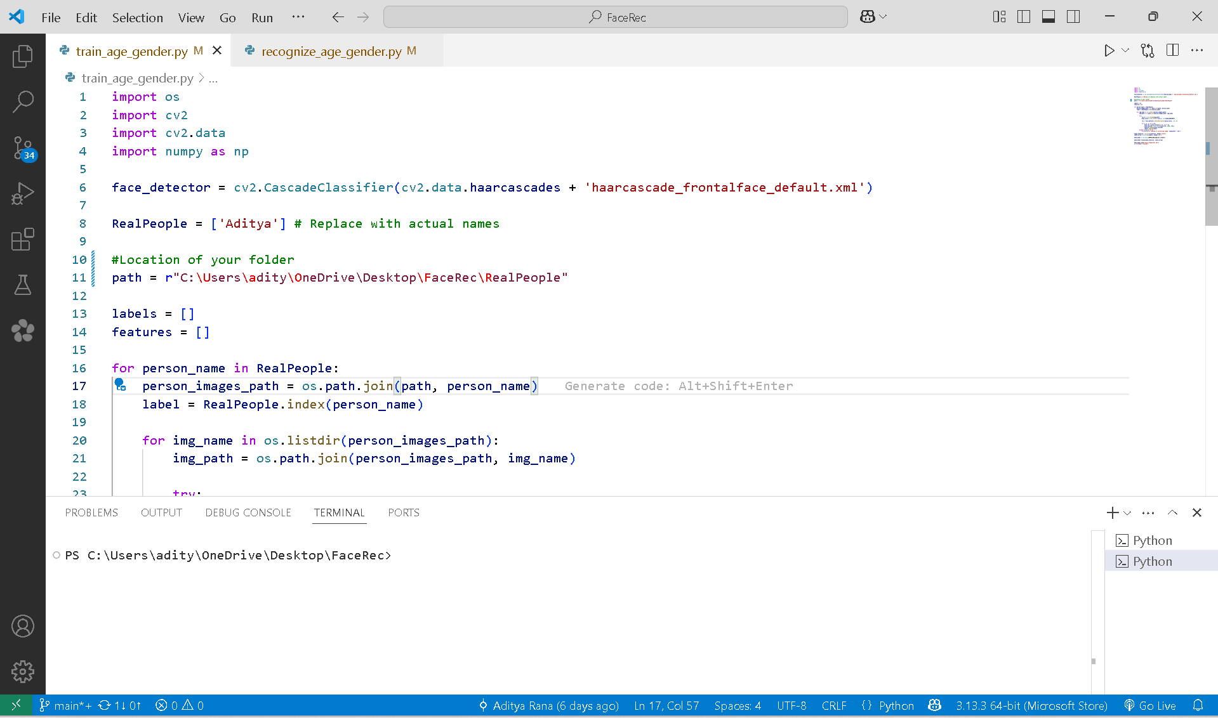

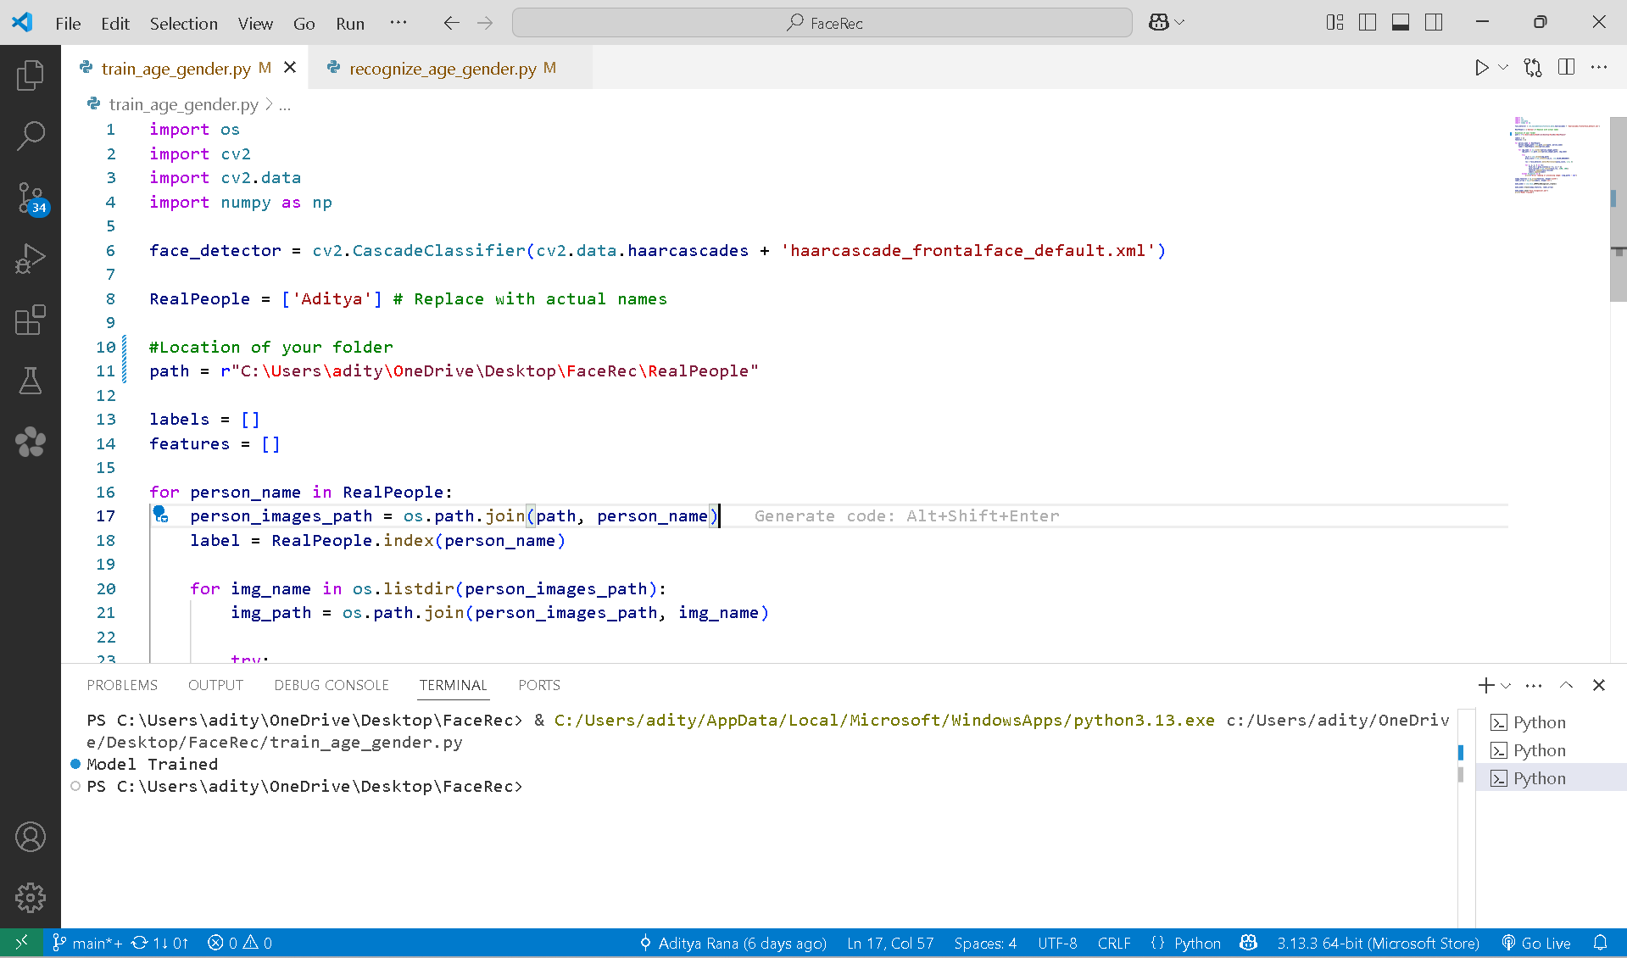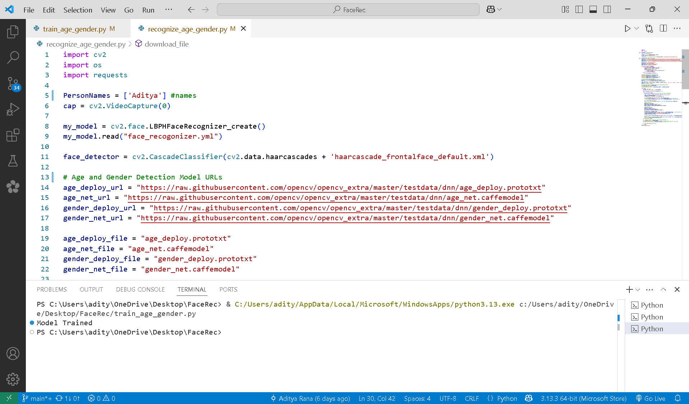

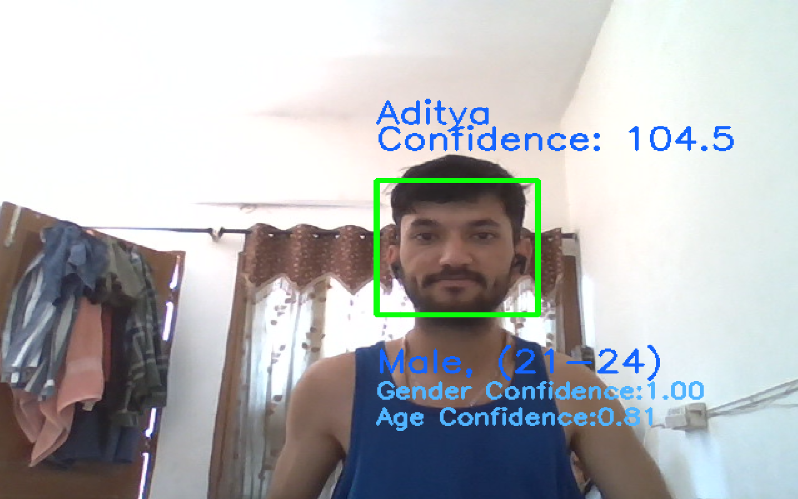

# CHAPTER 8



**TESTING**

## TESTING:

The Testing Phase is a critical part of the System Development Life Cycle

(SDLC) and plays a crucial role in ensuring the quality and reliability of the

software product. It is the systematic process of executing a program or system

with the intent of finding errors. The primary objective of this phase is to identify

and fix any defects, bugs, or issues in the software before it is considered ready

for use or deployment. This rigorous phase involves a series of systematic

activities designed to verify that the software meets all specified functional and

non-functional requirements, functions as expected under various anticipated

conditions and edge cases, and is robust and free from critical bugs that could

impact its performance, stability, or security. For the **FACEREC** project, which

deals with real-time processing of sensitive visual data, the testing phase is

absolutely essential to ensure that the real-time face detection, recognition, age

estimation, and gender classification functionalities are accurate, performant,

reliable, and can handle the variability inherent in live video feeds.

1. **Objectives of the Testing Phase**

The testing phase for **FACEREC** is guided by several key objectives, all aimed at

delivering a functional and reliable system:

* + **Validation:** The core of validation is ensuring that we built the *right* system. This objective focuses on confirming that the FACEREC system meets the functional requirements as defined in the Requirements Specification document – meaning it correctly performs the intended tasks like accurately detecting faces in a video frame, successfully recognizing known individuals from the training set, and providing reasonable estimations for age and gender. It also involves validating the non-functional requirements, such as processing frames quickly enough to achieve real-time performance and maintaining an acceptable level of accuracy for all analysis tasks under typical operating conditions.
  + **Verification:** Verification, in contrast to validation, ensures that we built the system *right*. This objective confirms that the system behaves correctly across a diverse range of scenarios and environments. For FACEREC, this is particularly important due to the variability of visual data. Verification involves testing under varying lighting conditions (bright sun, dim light), different facial angles (frontal, profile), the presence of multiple faces in the frame, and varying distances of individuals from the camera. This systematic checking of the output against expected results for known inputs helps to build confidence in the system's robustness.
  + **Bug Identification and Resolution:** A primary goal of testing is to uncover defects, errors, or inconsistencies in the software's code or logic. For FACEREC, this could include identifying issues like the face detector failing to detect faces under specific conditions, the recognition module incorrectly identifying a person or failing to recognize a known individual, inaccurate age/gender estimations for certain demographics, performance bottlenecks causing noticeable lag in the video feed, or even application crashes when encountering unexpected input or conditions. Once identified, these bugs are systematically logged, analyzed, and fixed by the development team to improve the system's stability and performance.
  + **Quality Assurance:** Ultimately, the testing phase serves as a critical gate for quality assurance. It is the final opportunity to ensure the FACEREC system is of high quality, reliable for continuous operation over extended periods, and performs its intended analysis tasks with a satisfactory level of accuracy and speed. This objective is met when the system passes all defined test cases and meets the predetermined exit criteria, signifying that it is stable and ready for its intended use, whether that be for demonstration, further development, or potential deployment in a specific application.

1. **Types of Testing Conducted**

To ensure comprehensive coverage and thorough validation of the **FACEREC**

system, various types of testing are conducted throughout the development

lifecycle:

* + **2.1. Unit Testing**
    - **Purpose:** Unit testing is the foundational level of testing, conducted to test individual components, modules, or even specific functions or methods of the software in isolation. The goal is to ensure that each discrete piece of the processing pipeline functions correctly on its own, producing the expected output for a given input, independent of other parts of the system.
    - **Activities:** Developers are typically responsible for writing and executing unit test cases for the code they develop. For FACEREC, this would involve creating tests for specific functions like the grayscale conversion function (input: color image, expected output: correct grayscale image), testing the output of the Haar Cascade detector with sample static images containing faces at known locations, or testing the LBPH prediction function by providing it with pre-cropped face ROIs from the training set and asserting that it returns the correct label and a reasonable confidence score. Testing might involve using testing frameworks in Python (though often done more informally in smaller projects) to provide sample image data or simulated inputs to a component and automatically checking if the output matches the expected result. Defects identified during unit testing (e.g., a function not handling edge cases correctly, an algorithm producing unexpected numerical values) are typically easier to diagnose and fix at this isolated level.
  + **2.2. Integration Testing**
    - **Purpose:** Integration testing follows unit testing and focuses on verifying the interactions and data flow between different modules or components of the software as they are connected in the processing pipeline. It ensures that the integrated modules work together seamlessly as expected and that data is passed correctly and efficiently between them without errors or inconsistencies.
    - **Activities:** Test cases are designed to test the data flow and interaction between connected components. For instance, testing if the raw video frame output by the Video Capture component is correctly received and processed by the Pre-processing component, or if the bounding boxes generated by the Face Detection component are accurately used to extract the corresponding face ROIs for the Face Recognition and Age/Gender Estimation components. Testing involves running sequences of components in the pipeline to see if data is passed and processed correctly across component boundaries. Issues related to interface compatibility, data format mismatches between components, or unexpected behavior that only emerges when modules interact are identified and resolved during this phase.
  + **2.3. System Testing**
    - **Purpose:** System testing is a comprehensive level of testing that involves testing the complete and integrated **FACEREC** system as a whole. This is where the system is tested in an environment that closely simulates the intended operational environment to ensure that it meets all the specified functional and non-functional requirements from an end-to-end perspective, as well as overall system behavior.
    - **Activities:** The entire FACEREC application is run using a live webcam feed, and its overall behavior is validated against the requirements. System testing covers both functional aspects (e.g., does it accurately detect, recognize, and classify faces in a live, dynamic scenario? Does it handle multiple faces simultaneously?) and non-functional aspects (e.g., is the performance acceptable, maintaining a smooth and responsive display? Is the system stable during prolonged use?). Test cases executed during system testing verify that the system meets requirements like real-time processing speed, overall accuracy of recognition and estimation under various real-world conditions, and stability during continuous operation. This might involve extensive testing with different webcams, in diverse environments with varying lighting and backgrounds, and with a wide range of individuals to assess robustness.
  + **2.4. User Acceptance Testing (UAT)**
    - **Purpose:** UAT is the final phase of testing before potential deployment or release, where the software is tested from the end-user's perspective. The goal is to ensure that the system meets their needs, is user-friendly, and that the output is presented in a clear and understandable manner. For **FACEREC**, if intended for use by others beyond the developer, this would involve potential users or stakeholders evaluating the system's usability and the clarity and usefulness of the visual output.
    - **Activities:** End-users or client representatives (if applicable) interact with the FACEREC application using a live video feed in a scenario that mimics real-world usage. Feedback from users is gathered regarding the clarity of the display (are the bounding boxes and text labels easy to see and understand?), the responsiveness of the system, and whether the recognition and analysis results are presented in a way that meets their expectations or requirements. UAT serves as the final verification and sign-off before the system is considered ready for its intended purpose.
  + **2.5. Performance Testing**
    - **Purpose:** Performance testing is specifically conducted to evaluate how the **FACEREC** system performs under various conditions, with a strong focus on its speed, efficiency, and responsiveness in real-time processing. This is crucial for a live video analysis application where lag can significantly degrade the user experience.
    - **Activities:** Activities include measuring key performance indicators such as the system's frame rate (how many frames per second are processed and displayed) and latency (the delay between an event happening in front of the camera and it being reflected in the displayed output). Testing is done to ensure the system maintains a smooth, real-time experience, ideally close to the webcam's native frame rate. This also involves evaluating performance with varying numbers of faces in the frame to see how the processing time scales and identifying potential bottlenecks in the processing pipeline that might be causing lag under heavy load. Testing on different hardware configurations (e.g., with and without a dedicated GPU if applicable) helps to understand performance characteristics and define minimum hardware requirements for acceptable performance.
  + **2.6. Security Testing**
    - **Purpose:** Security testing aims to identify vulnerabilities in the software that could be exploited, particularly concerning the handling of sensitive data like facial images and the security of model files. While FACEREC in an academic context might not require enterprise-level security, understanding potential risks is important.
    - **Activities:** Activities could include reviewing how training data (images of individuals) and trained model files (face_recogonizer.yml) are stored and accessed to ensure they are protected from unauthorized access or tampering. Considering potential risks related to the video feed itself is also important, especially in a deployment scenario where privacy is a concern – ensuring video data is not inadvertently exposed or stored insecurely. While not involving penetration testing for this type of project, it involves reviewing the code for obvious security flaws and ensuring that the application does not introduce vulnerabilities to the system it runs on.

1. **Testing Tools and Techniques**

To facilitate the testing process for **FACEREC**, various tools and techniques can

be employed to systematically evaluate the system:

* + **Manual Testing:** This is a fundamental technique for FACEREC, involving directly running the application and visually observing its behavior under different conditions. This includes testing with different individuals, in various lighting environments (bright, dim, uneven), with faces at different angles and distances, and with varying numbers of faces in the frame. The tester manually verifies if faces are detected, if recognition is correct, and if age and gender estimations seem reasonable, while also observing the smoothness of the video feed.
  + **Sample Image/Video Testing:** Using a predefined set of static images or short video clips with known outcomes is a more controlled testing technique. For example, a set of images of known individuals can be used to test recognition accuracy. Videos with individuals of known age ranges and genders can be used to test the estimation accuracy. This allows for repeatable testing and easier comparison of results across different versions of the software.
  + **Debugging Tools:** Utilizing Python debugging tools within an IDE (like Visual Studio Code or PyCharm) is essential for identifying the root cause of errors or unexpected behavior. Debuggers allow developers to pause the execution of the code, step through it line by line, inspect the values of variables (such as image data, bounding box coordinates, prediction results, confidence scores) at different points in the pipeline, and understand the program's flow, which is invaluable for diagnosing issues.
  + **Performance Monitoring Tools:** Using system monitoring tools (provided by the operating system) or profiling techniques within Python can help measure the execution time of different parts of the code and identify performance bottlenecks. This allows developers to pinpoint which components or operations are taking the most time and optimize them to improve the real-time performance of the system.
  + **Logging:** Implementing logging within the code is a valuable technique for recording events, errors, warnings, and key processing steps during the application's execution. This creates a log file that can be reviewed later to diagnose issues that might occur during testing, especially in scenarios that are difficult to reproduce consistently. Logging information about detected faces, recognition outcomes, and prediction results can provide valuable data for analysis.

1. **Reporting and Documentation**

Throughout the testing phase, detailed documentation is maintained to record the

test cases executed, the testing procedures followed, and the outcomes observed.

This documentation is crucial for tracking progress, communicating findings, and

ensuring transparency in the testing process. Key documents for the **FACEREC**

project might include:

* + **Test Scenarios/Cases:** Detailed descriptions of the specific tests to be performed. Each test case outlines the input conditions (e.g., "Test recognition with Person X in low light"), the expected outcome (e.g., "Face detected, Person X recognized with confidence below threshold Y"), and provides space to record the actual result observed during testing. This provides a structured approach to testing and allows for repeatability.
  + **Defect Log:** A centralized record of all identified bugs or issues. Each entry in the defect log includes a unique identifier, a clear description of the problem, steps to reproduce the issue, the severity level (e.g., Critical, High, Medium, Low), the component affected, and the current status (e.g., New, In Progress, Fixed, Closed, Cannot Reproduce). Including screenshots or short video clips of the issue can significantly help developers understand and fix the problem.
  + **Test Summary Report:** A comprehensive report generated at the end of a testing cycle or the entire testing phase. This report summarizes the results of the testing activities, including the total number of test cases executed, the number of defects found and their distribution by severity, the number of defects fixed, the overall performance observed (e.g., average frame rate), and an assessment of whether the system meets the defined exit criteria. This report provides stakeholders with a clear overview of the system's quality and readiness.

1. **Defect Management**

Defect management is an integral and ongoing process throughout the testing

phase for **FACEREC**. It involves a systematic approach for handling issues

found during testing to ensure they are tracked, prioritized, and resolved

efficiently:

* + **Defect Logging:** When a tester identifies a bug, they log it in a defect tracking system (even a simple spreadsheet or document for a small project). The log entry includes all relevant details to help the developer understand and reproduce the issue (description, steps to reproduce, environment details, screenshots/videos if possible).
  + **Defect Prioritization:** Defects are classified based on their severity (how much impact they have on the system's functionality or stability) and priority (how quickly they need to be fixed). A critical bug that crashes the application would be high severity and high priority, while a minor visual inconsistency might be low severity and low priority.
  + **Defect Resolution:** Developers review the logged defects, investigate the root cause, and implement code changes to fix the issues.
  + **Retesting:** After a defect is fixed, the tester who originally reported it (or another tester) re-executes the specific test case that revealed the defect to confirm that the issue has been resolved correctly and the fix works as expected.
  + **Regression Testing:** An important part of defect management is regression testing. After fixes or new features are implemented, regression testing involves re-running a subset of previously passed test cases (especially those covering core functionalities) to ensure that the new code changes have not introduced new bugs or negatively impacted existing, previously working functionality. For FACEREC, this would mean re-testing basic detection and recognition after adding the age/gender estimation feature, for example.

1. **Exit Criteria**

The testing phase for **FACEREC** concludes when the predefined exit criteria are

met. These criteria signal that the system is deemed stable, performs

adequately according to the project's goals, and is ready to move to the next phase

(e.g., deployment or further development). Typical exit criteria for FACEREC

would include:

* + **Test Case Execution Completion:** All planned key test scenarios and test cases (covering detection, recognition, age, gender, and basic performance under various conditions) have been executed.
  + **Critical Defect Closure:** All critical and high-priority defects (e.g., application crashes, consistent failure to detect faces, major recognition errors, significant performance degradation) have been identified, fixed, and verified as resolved through retesting.
  + **Performance Thresholds Met:** The system demonstrates acceptable real-time performance, meeting or exceeding predefined thresholds for frame rate and latency on the target hardware. For instance, the system might need to maintain a minimum of 15-20 frames per second for a smooth real-time experience.
  + **Accuracy Levels Achieved:** The accuracy of face detection, recognition, age estimation, and gender classification are deemed satisfactory based on testing with representative data and scenarios, aligning with the project's objectives and any defined accuracy targets. While perfect accuracy is often unattainable in real-world computer vision, the system should perform reliably within expected parameters.
  + **System Stability:** The system has been tested for a sufficient period without encountering unexpected crashes or major errors, demonstrating overall stability.
  + **Documentation Completion:** Key testing documentation (test cases, defect log, test summary report) is completed and reviewed.

Meeting these exit criteria provides confidence that the FACEREC system is

robust enough for its intended purpose and represents a stable baseline for any

future development or application.

# CHAPTER 9



**DEPLOYMENT**

## DEPLOYMENT:

The Deployment Phase is a crucial stage in the System Development Life Cycle

(SDLC), where the completed software product is prepared and made ready for

use in its intended environment. This phase involves several steps to ensure that

the software is properly installed, configured, and functioning correctly on the

user's computer. For the **FACEREC** project, which is a standalone application for

real-time face analysis, deployment means getting the Python script and its

necessary files onto a computer with a webcam and ensuring it runs as expected.

1. **Objectives of the Deployment Phase**

The deployment phase for **FACEREC** aims to achieve the following objectives:

* **Installation and Configuration:** Ensure that the Python script and all required external files (like the trained recognition model and pre-trained age/gender models) are correctly placed and configured on the target computer. This also includes verifying that the necessary software dependencies are met.
* **Environment Readiness:** Confirm that the target computer has the required software (Python, OpenCV, NumPy, Requests) and hardware (a working webcam) installed and properly set up for the application to run.
* **Functional Verification:** Perform final checks to confirm that the FACEREC application starts and operates as expected in the live operational environment (i.e., using the actual webcam feed on the user's machine).
* **User Readiness (if applicable):** If the system is intended for use by someone other than the developer, provide simple instructions on how to run the application and any basic troubleshooting steps.
* **Transition to Operation:** Successfully transition the project from the development and testing environment to a state where it can be run by the user for real-time face analysis.

1. **Deployment Process**

The deployment process for a standalone Python application like FACEREC is

generally simpler than deploying a large web system. The key steps involved in

this process include:

* **2.1. Deployment Planning**
  + - **Objective:** To prepare a simple plan outlining the necessary files, software requirements, and steps for getting the application running on a target machine.
    - **Activities:**
      * Identify all necessary files: the main Python script, the trained face_recogonizer.yml file, and the pre-trained DNN model files (.prototxt and .caffemodel).
      * List the required software dependencies: Python, OpenCV, NumPy, and Requests libraries.
      * Note the hardware requirement: a functional webcam.
      * Prepare clear, step-by-step instructions for the user on how to install dependencies and run the script.
* **2.2. Environment Setup**
  + - **Objective:** To ensure that the target computer is ready to run the FACEREC software.
    - **Activities:**
      * Verify that Python is installed on the target machine.
      * Install the required Python libraries (OpenCV, NumPy, Requests) using package managers like pip (e.g., pip install OpenCv-python Numpy requests).
      * Confirm that a webcam is connected and recognized by the operating system.
  + **2.3. Software Installation**
    - **Objective:** To transfer the FACEREC project files to the target computer.
    - **Activities:**
      * Copy the main Python script (.py file) to a desired location on the target machine.
      * Ensure the trained face_recogonizer.yml file is in the same directory as the script, or provide instructions on where to place it.
      * The pre-trained DNN model files will ideally be downloaded automatically by the script if they are not found, simplifying this step.
  + **2.4. Data and Model File Placement**
    - **Objective:** To ensure the necessary model files are accessible to the application.
    - **Activities:**
      * Place the trained face_recogonizer.yml file in the expected location (usually the same directory as the script).
      * Ensure the script has the necessary permissions to download and save the DNN model files if they are not already present.
  + **2.5. Final Testing and Validation**
    - **Objective:** To perform a final check in the actual operational environment to ensure the software runs and performs as expected.
    - **Activities:**
      * Run the main Python script on the target machine.
      * Verify that the webcam feed is displayed correctly.
      * Check if faces are detected and bounding boxes appear.
      * Observe if known individuals are recognized and if age/gender estimations are displayed.
      * Confirm that the application runs smoothly without significant lag and can be exited using the designated key ('e').

1. **User Guidance and Documentation**

A successful deployment includes preparing the user to effectively run the

system. This involves:

* + **Simple Instructions:** Providing clear, concise steps on how to set up the environment (install Python and libraries) and run the main script.
  + **Prerequisites Checklist:** Listing the required software and hardware upfront.
  + **Basic Troubleshooting:** Including tips for common issues, such as ensuring the webcam is connected or verifying that model files were downloaded successfully.

1. **Go-Live**

For FACEREC, the "go-live" step is simply running the main Python script on the

target machine.

* + **Running the Application:** The user executes the Python script from the command line or a file explorer.
  + **Real-Time Operation:** The application starts capturing the webcam feed and begins performing real-time face analysis, displaying the results in a window.

1. **Post-Deployment Activities**

After the application is running, some ongoing activities might be relevant:

* + **Performance Observation:** The user might observe the system's performance on their specific hardware and note any lag or issues.
  + **Feedback Collection (if applicable):** If the project is shared, collecting feedback on its usability and performance can inform future improvements.
  + **Planning for Updates:** If the face recognition model needs to be updated with new individuals, the training process would need to be performed again, and the new face_recogonizer.yml file would need to be deployed. Updates to the script itself would also involve replacing the existing file.

1. **Challenges and Mitigation Strategies**

Deployment of FACEREC might present some challenges:

* + **Dependency Installation:** Users might encounter issues installing Python or the required libraries (OpenCV, NumPy, Requests) due to system configurations or compatibility issues. Mitigation involves providing clear installation instructions and potentially troubleshooting common errors.
  + **Webcam Compatibility:** Not all webcams might be fully compatible with OpenCV, leading to capture issues. Mitigation could involve suggesting common webcam types or providing guidance on checking webcam functionality outside the application.
  + **Performance Variations:** The real-time performance can vary significantly based on the target computer's processor and RAM. Mitigation involves setting realistic expectations about performance based on hardware or suggesting minimum hardware specifications for optimal results.
  + **Model File Access:** Issues with downloading or accessing the DNN model files can prevent age and gender estimation from working. Mitigation involves ensuring the download logic is robust and providing manual download options if needed.

# CHAPTER 10



**CONCLUSION**

## CONCLUSION:

The **FACEREC** project represents a significant achievement in developing a real-time system for analyzing human faces from a live video feed. The project's core objective was to create a functional application capable of performing face detection, recognizing known individuals, and estimating age and gender in real-time.

Through a systematic approach guided by the System Development Life Cycle (SDLC), the project has successfully met these objectives. The initial phase involved a thorough **Requirement Analysis**, defining the specific functional needs for capturing video, processing frames, detecting faces, performing recognition, estimating age and gender, and visualizing the results in real-time. This phase also considered crucial non-functional requirements such as performance (real-time speed) and accuracy.

The **Software Design** phase translated these requirements into a structured blueprint, outlining a processing pipeline architecture where video frames flow sequentially through different analysis components. This design focused on modularity, allowing for clear separation of tasks like video capture, pre-processing, detection, recognition, and age/gender estimation. The design also considered the data flow between these components and the simple user interface for displaying results.

The **Implementation** phase involved writing the actual Python code, leveraging powerful libraries like OpenCV and NumPy. This is where the algorithms for face detection (Haar Cascades), face recognition (LBPH), and age/gender estimation (pre-trained DNNs) were integrated and coded to work together within the defined pipeline structure. The code also handles loading necessary model files and overlaying results onto the video feed.

The **Testing** phase was crucial for validating the system's performance and accuracy. This involved testing the system with live video under various conditions to ensure that faces were reliably detected, known individuals were correctly recognized (within acceptable confidence thresholds), and age/gender estimations were reasonably accurate. Performance testing focused on ensuring the system processed frames fast enough to provide a smooth, real-time experience.

Finally, the **Deployment** considerations focused on making the standalone Python application runnable on a target computer with a webcam, ensuring the necessary software dependencies were met and the required model files were accessible.

As the project reaches its conclusion, **FACEREC** stands as a functional system capable of demonstrating real-time face analysis. It provides a visual output showing who is detected, their estimated age and gender, and if they are recognized from a trained set.

The successful completion of this project highlights the importance of a well-structured development process, even for a focused application. It demonstrates the practical application of computer vision and machine learning techniques for analyzing facial data in real-time. The project has not only achieved its initial goals of implementing detection, recognition, age, and gender estimation but has also laid the groundwork for future enhancements and expansions, such as incorporating emotion detection, utilizing more advanced deep learning models for improved accuracy, or integrating the system into other applications. **FACEREC** is designed with a modular structure that facilitates such future development.

# CHAPTER 11



**BIBLIOGRAPHY**

## BIBLIOGRAPHY:

During the analysis and execution phases of the **FACEREC** project, various resources were consulted to ensure a comprehensive understanding of the technologies and methodologies employed in real-time face analysis. The following books and websites were instrumental in providing the necessary knowledge and guidance for the development of this project:

**Books**

1. **Learning OpenCV 3: Computer Vision in C++ with the OpenCV Library**
   * Authors: Gary Brad ski, Adrian Kaehler
   * Publisher: O'Reilly Media
   * Edition: Third Edition
   * Summary: Although primarily focused on C++, this foundational book provides in-depth explanations of core computer vision concepts and the structure and functionalities of the OpenCV library. It was invaluable for understanding the underlying principles of image processing, object detection (like Haar Cascades), and basic machine learning techniques relevant to face analysis, serving as a comprehensive reference for using OpenCV's capabilities.
2. **Python Machine Learning**
   * Author: Sebastian Raschka
   * Publisher: Packt Publishing
   * Edition: Third Edition
   * Summary: This book offers a broad introduction to machine learning concepts and algorithms using Python libraries like NumPy and scikit-learn. While FACEREC uses a specific algorithm (LBPH) and pre-trained models, this book's sections on data handling with NumPy and fundamental machine learning principles provided useful context and techniques applicable to the data processing aspects of the project.
3. **Deep Learning with Python**
   * Author: François Chollet
   * Publisher: Manning Publications
   * Edition: First Edition
   * Summary: This book provides a practical, hands-on introduction to deep learning using the Keras library (which can be integrated with TensorFlow or PyTorch). While FACEREC uses pre-trained DNN models via OpenCV's DNN module rather than training from scratch, understanding the basic concepts of neural networks, layers, and model architectures from this book was helpful for comprehending how the age and gender estimation models’ function.

**Websites**

1. **OpenCV Official Documentation - docs.opencv.org**
   * Summary: The official documentation for OpenCV is an indispensable resource. It provides detailed API references for all OpenCV functions and modules (including cv2.VideoCapture, cv2.CascadeClassifier, cv2.face, cv2.dnn, and drawing functions), tutorials on various computer vision tasks, and explanations of algorithms. It was a primary source for understanding how to implement specific functionalities within the FACEREC project.
2. **Stack Overflow - stackoverflow.com**
   * Summary: Stack Overflow was a crucial resource for troubleshooting specific coding challenges, finding solutions to common errors encountered while working with Python and OpenCV, and gaining insights from the experiences of other developers in the computer vision community. The community-driven platform provided practical answers and alternative approaches to problems.
3. **NumPy Official Documentation - numpy.org/doc/**
   * Summary: The official documentation for NumPy provides comprehensive information on array manipulation, mathematical functions, and data structures. As OpenCV heavily relies on NumPy arrays for image representation, this documentation was valuable for understanding how to efficiently handle and process image data within the Python environment.
4. **Towards Data Science - towardsdatascience.com**
   * Summary: This platform hosts numerous articles and tutorials on data science, machine learning, and computer vision topics. Searching this site provided practical examples, explanations of concepts, and guides on implementing specific techniques relevant to face analysis, often including code snippets using Python and OpenCV.
5. **Real Python - realpython.com**
   * Summary: Real Python offers high-quality tutorials and articles on various Python topics, including working with libraries like OpenCV and NumPy. It was a valuable resource for learning Python programming best practices and specific techniques applicable to the project.
6. **PyImageSearch - pyimagesearch.com**
   * Summary: PyImageSearch provides extensive tutorials and resources specifically focused on computer vision and deep learning using Python and OpenCV. It was a practical source for learning how to implement face detection, recognition, and other related computer vision tasks.

These resources collectively contributed to the successful completion of the **FACEREC** project, offering the necessary knowledge and support at each stage of development, from understanding the underlying algorithms to implementing the real-time processing pipeline.